**Compilation Image**



**Program1B LOC**

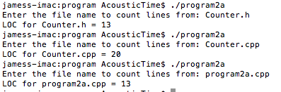

**Program2A LOC**

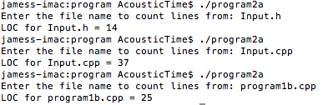

**Test Results Table**

|  |  |
| --- | --- |
| **Program Number** | **LOC** |
| 1B | Counter.h = 13  Counter.cpp = 20  Program1B.cpp = 13  **Total LOC = 46** |
| 2A | Input.h = 14  Input.cpp = 37  Program2a.cpp = 25  **Total LOC = 76** |